Hello ,

Please Edit attached files.

Hating kapatid kayong tatlo , Judith is 'ASAP.'.

exmple: notice d highlighted area naka same row tanan

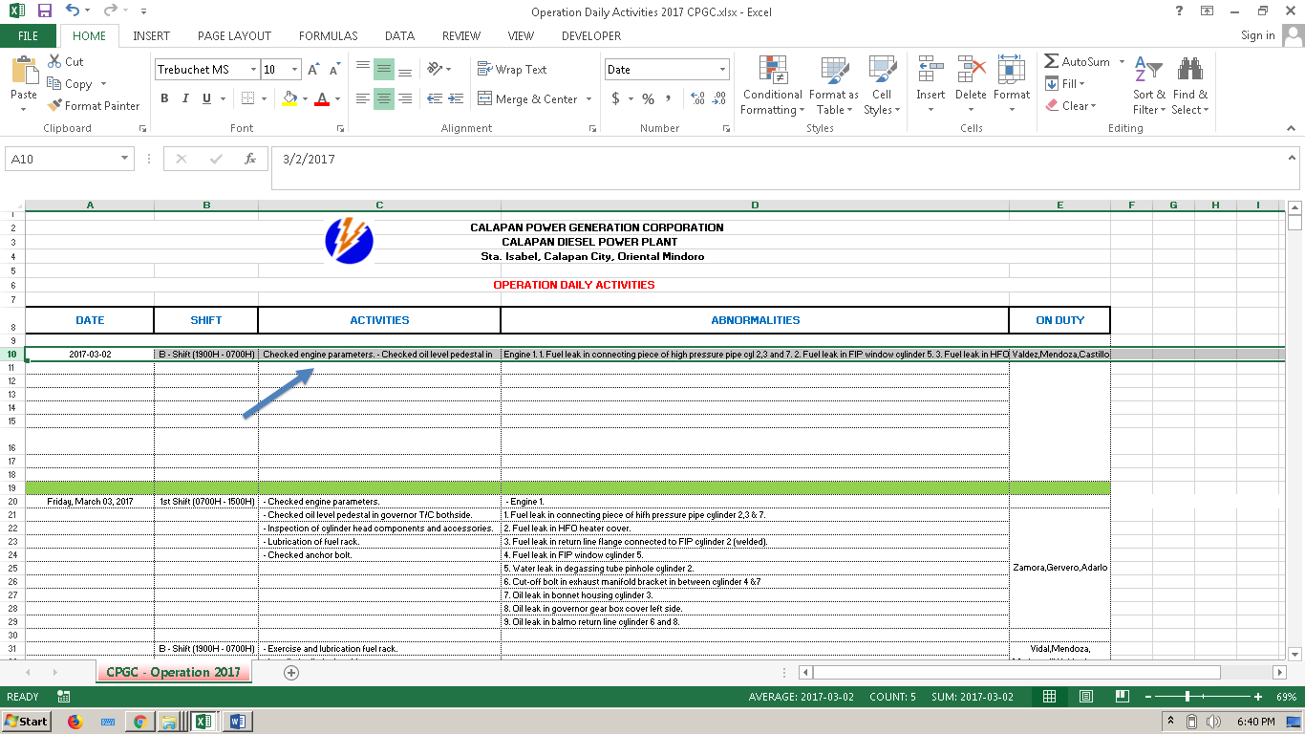

 -ang date e format cell nyo lng y-m-d(2018-06-31).

- Merge nyo ang 'Activities' kag 'Abnormalities'

- If there are 3 shifts in a day dapat 3 rows na sya 1st 2nd and third shift,  butang lng date sa 2nd kag 3rd shift kay ang una lng na shift ang my date..

-kag ang ‘on duty’ dapat naka same row man sya, 1swt 2nd or 3rd shft..

Note: sundin nyo lng yong format na nka highlight.

Thanks,

--

Lloyd G. Jamero

Central Negros Power Reliability Inc. (CENPRI)

Phone No. 09087636105